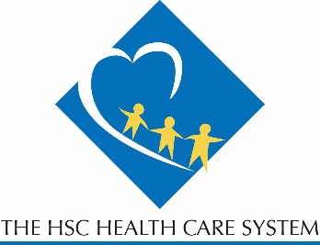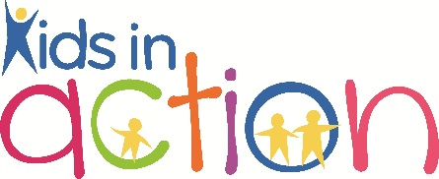 

For more information about the program of Kids in Action please contact Robyn Cohen, CTRS at 202-557-1851 or [rwinston@hospsc.org](mailto:rwinston@hospsc.org) www.facebook.com/HSCKidsInAction

We are currently seeking volunteers for our spring adaptive martial arts program! This would be a great opportunity for students to gain hands-on experience working with children who have a variety of disabilities. Classes are taught by our OT with a 2nd degree black belt.

Volunteer Requirements:

*NO MARTIAL ARTS EXPERIENCE NECESSARY!*

* Be able to commit to attend classes for 8 consecutive weeks.
* Comfortable working 1:1 with participants.
* Must be at least 16 years of age.
* Must complete a background check and online training module prior to start date.
* Classes begin Wednesday evenings on April 15 and end June 3rd.
* Classes Times:
* 5:15 to 6:00pm
* 6:15 to 7:00 pm
* Takes place at the HSC Pediatric Center’s conferences rooms

# MARTIAL ARTS

# Brought to you by The HSC Pediatric Center’s Kids in Action Program

The HSC Pediatric Center

1731 Bunker Hill RD NE

Washington DC 20017